Project Overview Template Project Characteristics

This document contains many project management related tables to be filled by the participants of the I3 course.

# Document version

Each time the document will be changed, please record in Table 1.

Table 1: Document version

|  |  |  |  |  |  |
| --- | --- | --- | --- | --- | --- |
| Nr. | Date | Version | Altered chapters | Type of altering | Author |
| 1 | 01.03.2020 | 1.1 | all | Creation | FirstName LastName |
| 2 | 03.03.2020 | 1.2 | 3.1 | Addition | FirstName2 LastName2 |
| 3 |  |  |  |  |  |
| 4 |  |  |  |  |  |
| 5 |  |  |  |  |  |

# Project information

*Please provide important facts for your project, e.g. acronym, title, proposed period, principal investigator and contractor.*

Table 2: Overall project information

|  |  |  |  |  |
| --- | --- | --- | --- | --- |
| Project |  | | | |
| Acronym |  | | | |
| Title |  | | | |
| Period | Start: |  | End: |  |
| Principal investigator |  | | | |
| Contractor |  | | | |

# Project Content and Project Goals

*Please provide an overview of your project with its main activities. Additionally give some information on the purpose, benefits and target groups as well as the proposed goals of your project. Please also provide explicit information on those aspects of the overall challenges, which you will not tackle with your project.*

Table 3: Project Content and Project Goals

|  |
| --- |
| Content & Goals |
| Project description *(~100-150 words)* |
|  |
| Project purpose, benefits and target group description *(~100 words)* |
|  |
| Project objectives (please also include a listing of the sub-goals) *(~100 words)* |
|  |
| Non-Goals |
|  |

# Frame of the project

*Please provide a description of the existing situation. Therefore, please describe the actual state and the identified challenges. As a second part, please also provide the most important information with regard to the proposed project period and the most important dates (Kick-off, interim/mid-term report/presentation, final report, paper submission etc.).*

Table 4: Frame of the project – Part 1

|  |
| --- |
| Context |
| Up-to-date status *(~50-100 words)* |
|  |
| Project setting *(~50 Wörter)* |
|  |

Table 5: Frame of the project – Part 2

|  |  |  |  |  |  |
| --- | --- | --- | --- | --- | --- |
| Time frame of the project | | | | | |
| Start: | | dd.mm.yyyy | | **End:** | dd.mm.yyyy |
| Important Dates | | | | | |
| 1 | dd.mm.yyyy | | Description | | |
| 2 | dd.mm.yyyy | | Description | | |
| 3 | dd.mm.yyyy | | Description | | |

# Resources & Budget

*Please provide information on the project lead and the project team. Please include information on name, role and qualification. Additionally provide information about the planned resources with regard to personal costs and other costs.*

Table 6: Resources and Budget – Part 1

|  |
| --- |
| Project Team |
| Project Lead |
|  |
| Project Team |
|  |

Table 7: Resources and Budget – Part 2

|  |
| --- |
| Resources |
| Personal costs |
|  |
| Project costs |
|  |
| Other Costs |
|  |

# Project structure, description and risk matrix

*Please provide a description about your work plan (work breakdown structure) your work packages in tabular and graphical form.*

## Work packages overview

Table 8: Work packages overview

|  |  |  |
| --- | --- | --- |
| WP | Name of the Work Package | Time Frame [to – from] |
| 1 | Project Management | dd.mm.yyyy – dd.mm.yyyy |
| 2 |  |  |
| 3 |  |  |
| 4 |  |  |
| 5 |  |  |
| 6 |  |  |
| 7 |  |  |

## Work Breakdown Structure (WBS)

Create a work breakdown structure for your work packages including the important tasks.

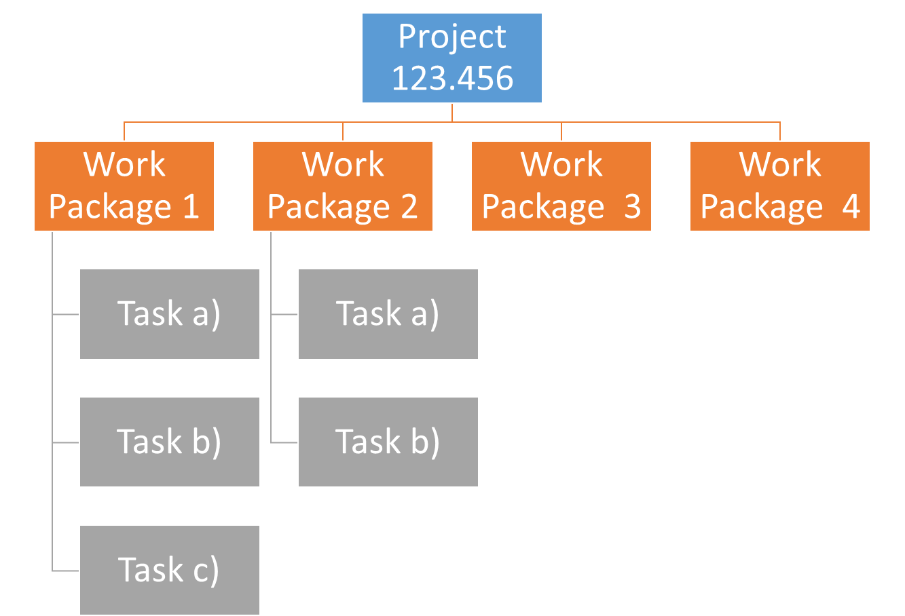

Figure 1 Work breakdown Structure

## Detailed work plan

*Please document the goals, content and expected results for each work package. Provide information on the planned approach and methods you want to apply as well as the expected results (including the planned milestones and deliverables). As a first work package please use ‘project management‘.*

Table 9: Detailled Work Plan – WP1

|  |  |  |  |
| --- | --- | --- | --- |
| WP 1 | Project management | Duration | dd.mm.yyyy – dd.mm.yyyy |
| Project Lead | **Project team** | | |
|  |  | | |
| Objectives | | | |
|  | | | |
| Content & Tasks | | | |
|  | | | |
| Expected results | | | |
|  | | | |
| Milestones & Deliverables | | | |
| M1  M2  D1  D2 | | | |

Table 10: Detailled Work Plan – WP2

|  |  |  |  |  |
| --- | --- | --- | --- | --- |
| WP 2 | […] | Duration | | dd.mm.yyyy – dd.mm.yyyy |
| Project Lead | | | **Project team** | |
|  | | |  | |
| Objectives | | | | |
|  | | | | |
| Content & Tasks | | | | |
|  | | | | |
| Expected results | | | | |
|  | | | | |
| Milestones & Deliverables | | | | |
| M1  M2  D1  D2 | | | | |

Table 11: Detailled Work Plan – WP*n*

|  |  |  |  |  |
| --- | --- | --- | --- | --- |
| WP n | […] | Duration | | dd.mm.yyyy – dd.mm.yyyy |
| Project Lead | | | **Project team** | |
|  | | |  | |
| Objectives | | | | |
|  | | | | |
| Content & Tasks | | | | |
|  | | | | |
| Expected results | | | | |
|  | | | | |
| Milestones & Deliverables | | | | |
| M1  M2  D1  D2 | | | | |

## Milestone plan

*Please provide a summary of the planned milestones and provide an according overview graphic.*

Table 12: Milestone plan

|  |  |  |
| --- | --- | --- |
| MS | Name | Date Completion |
| M1 | Milestone description | dd.mm.yyyy |
| M2 | Milestone description | dd.mm.yyyy |
| M3 | Milestone description | dd.mm.yyyy |
| M4 | Milestone description | dd.mm.yyyy |
| M5 | Milestone description | dd.mm.yyyy |

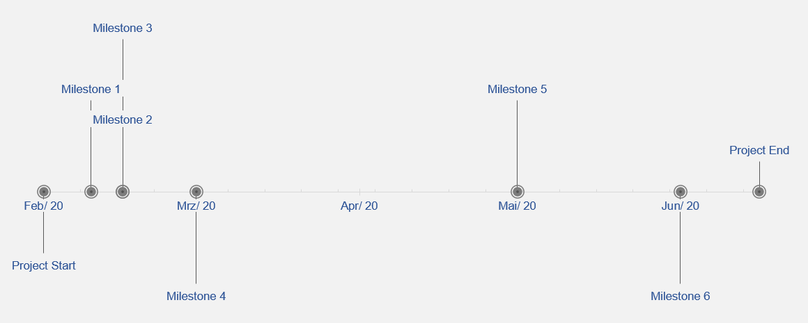

Figure 2 Milestones (from Excel template)

## Gantt Chart

*Please provide an image of your Gantt chart as overview graphics. Please attach the Gantt chart and its monthly updates in addition to this document.*

Table 13: Milestone plan

*[place the table here]*

## Risk Matrix

*In this table, please provide the important risk information. Please categorize the risks accordingly. ([****L****]ow, [****M****]edium, [****H****]igh], [****C****]leared) as well as your mitigation strategy. Please update this list accordingly during your project execution time frame.*

Table 14: Risk matrix

|  |  |  |  |  |  |
| --- | --- | --- | --- | --- | --- |
| No | Risk | Potential adverse impact | Risk level* | Risk management strategy | Responsibility |
|  |  |  |  |  |  |
|  |  |  |  |  |  |
|  |  |  |  |  |  |
|  |  |  |  |  |  |
|  |  |  |  |  |  |

# Additional comments

*Add additional comments if necessary.*

Table 15: Additional comments

|  |
| --- |
| Comments |
|  |

# Approval

*Please provide further information if necessary.*

Table 16: Approval

|  |  |  |  |
| --- | --- | --- | --- |
| Freigabe | | | |
| Date: | dd.mm.yyyy | **Date**: | dd.mm.yyyy |
|  | |  | |
| Signature principal investigator | | Signature project lead/contractor | |

# Attachments

*Attachment 1: Gantt chart (biweekly updated).*