Iceland – Electricity Production 2015
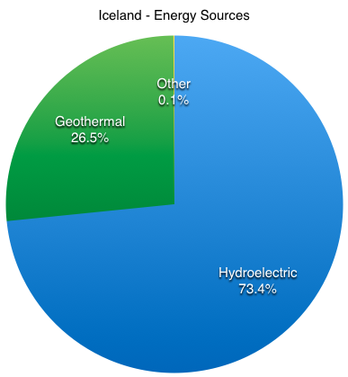

https://karanbijanireykjavik.weebly.com/energy-consumption.html
https://www.government.is/topics/business-and-industry/energy/

Stromerzeugung nach Energieträgern Österreich 2017

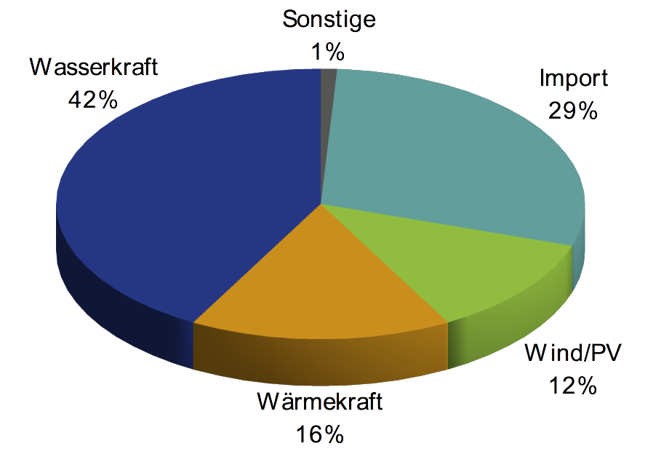

https://www.global2000.at/der-strom-filz-oesterreich
Iceland
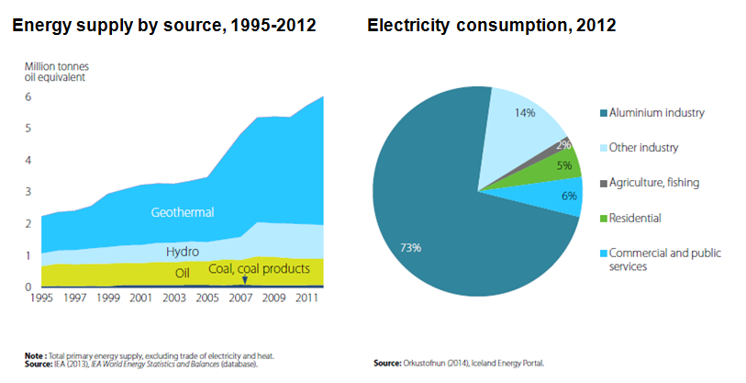
https://www.oecd.org/newsroom/iceland-must-balance-growth-in-power-and-tourism-industries-with-nature-conservation.htm

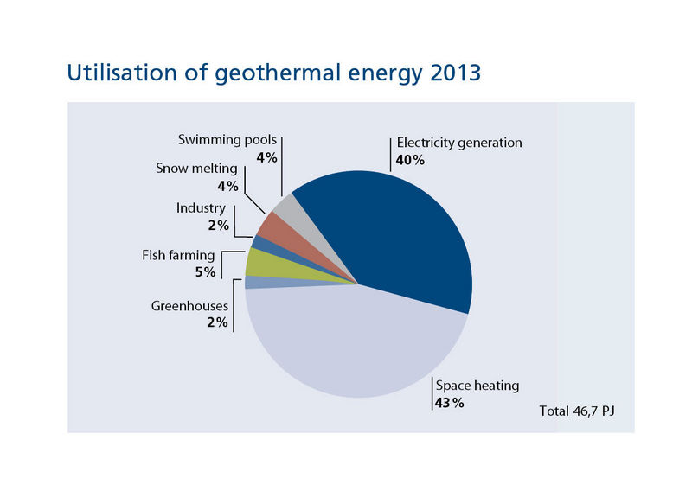
https://nea.is/geothermal/direct-utilization/https://nea.is/geothermal/direct-utilization/

